

**Sign Up**

**Login**

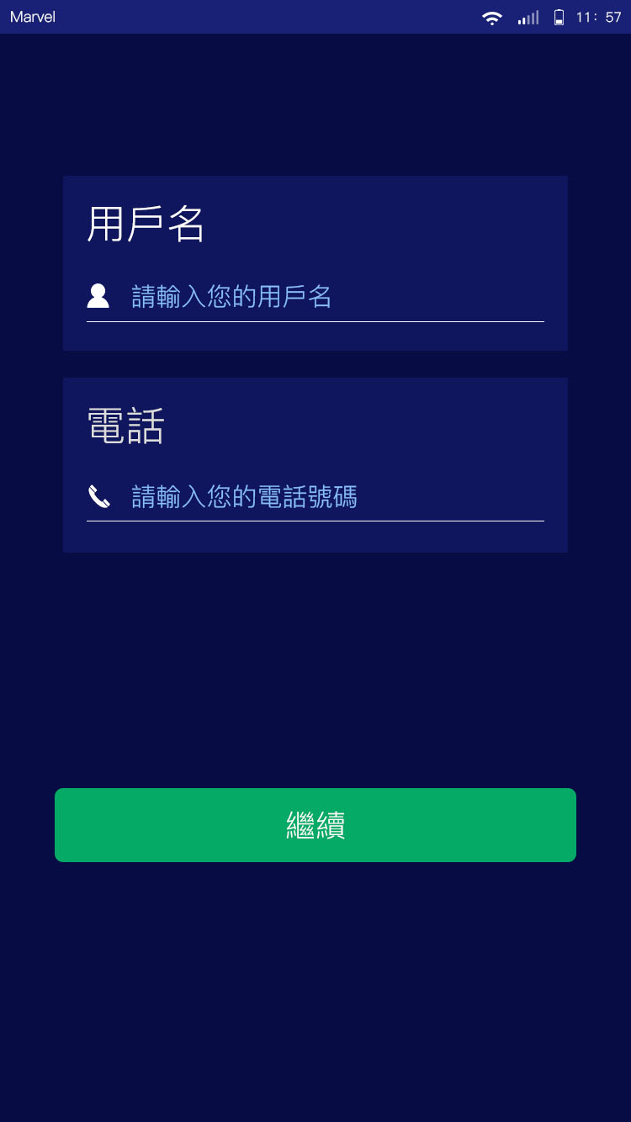

**Next**

**Mobile**

Please enter your phone number

**Username**

Please enter your username

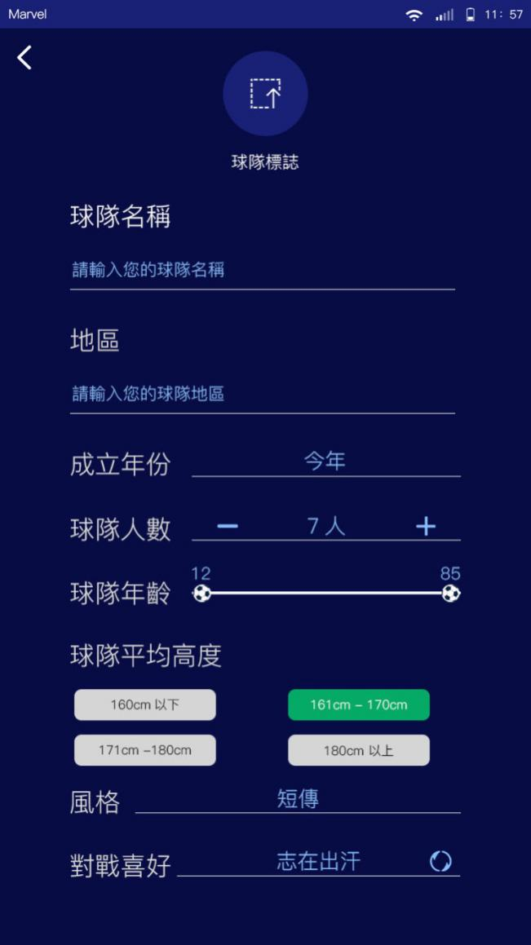

**Team Name**

Please enter your team name

**District**

Please enter your team district

**Established Year**

2016

2017

This year

**Number of Players**

7

**Age Range of Players**

12 - 85

**Average Height of Players**

160cm or below

161cm – 170cm

171cm – 180cm

Above 180cm

**Style**

Defensive

Offensive

Short pass

Long pass

**Match Preference**

Non-competitive

Competitive

**Team Logo**

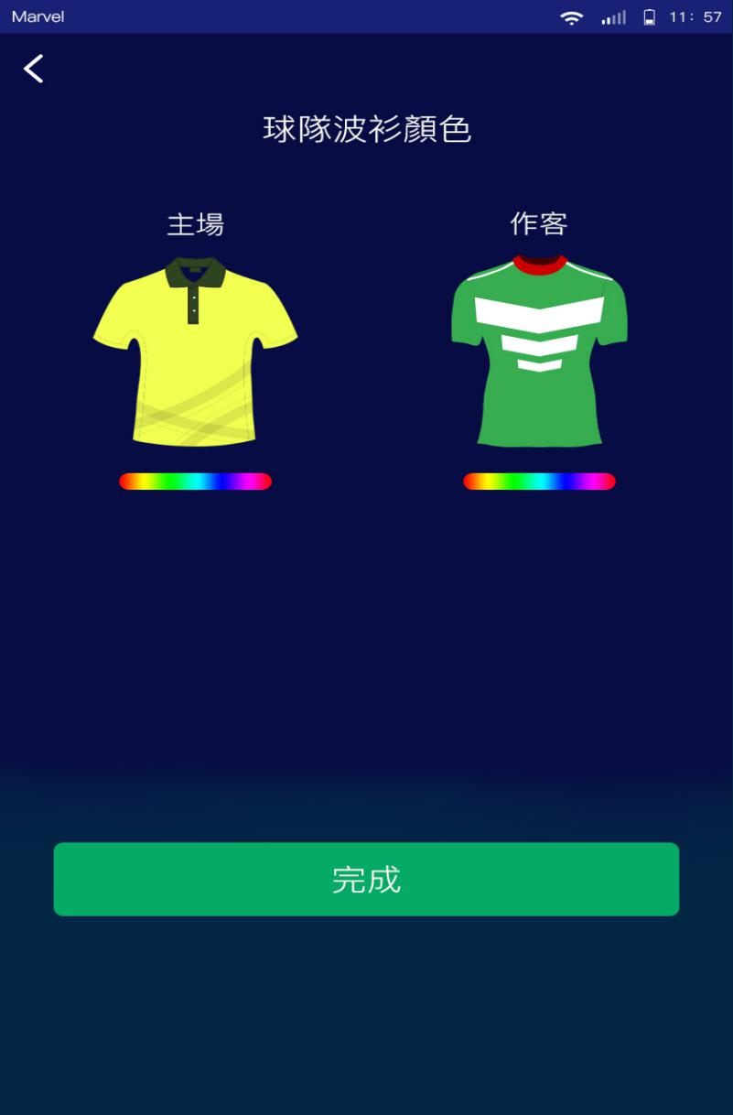

**Done**

**Home Away**

**Team Jersey Color**

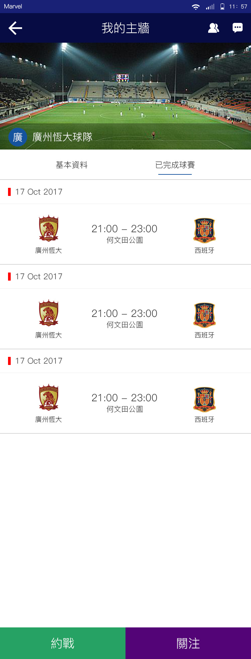

**Follow**

**Match Up**

**Completed Matches**

**Basic Information**

**My Wall**

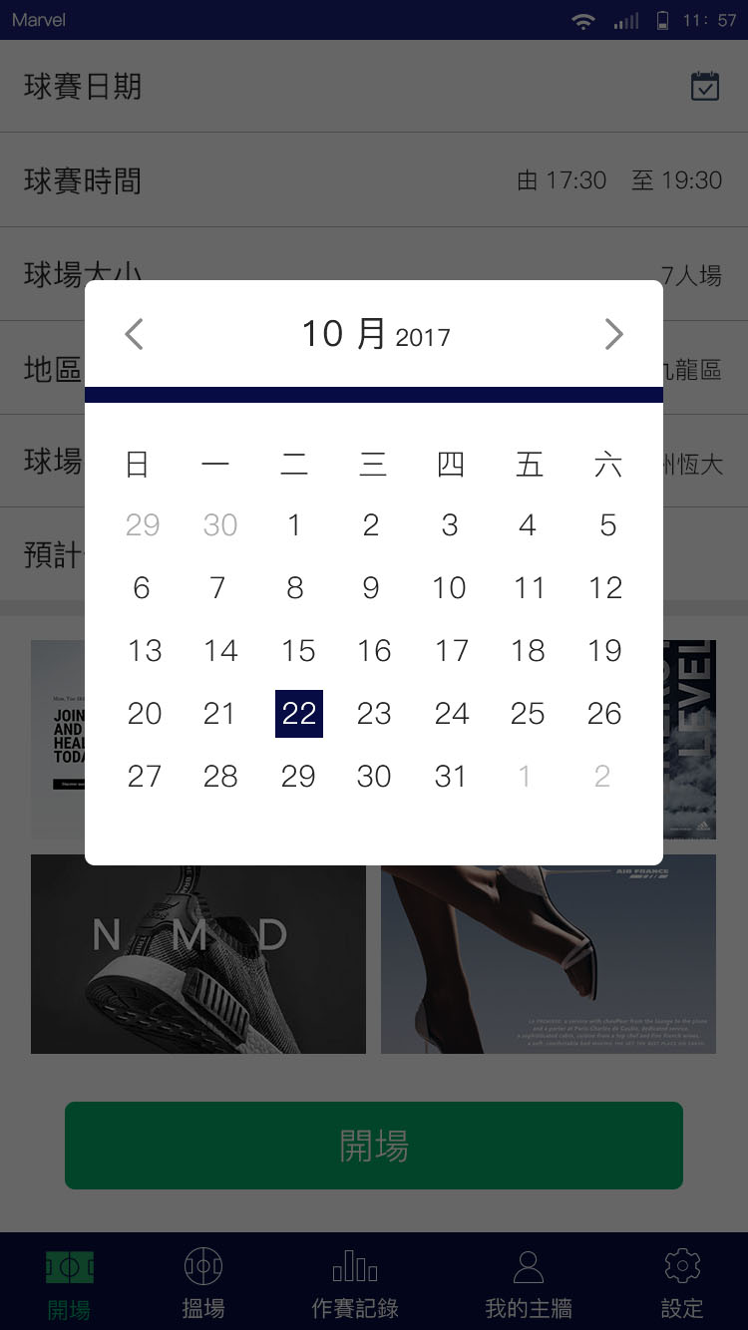

January 2017

February 2017

March 2017

April 2017

May 2017

June 2017

July 2017

August 2017

September 2017

October 2017

November 2017

December 2017

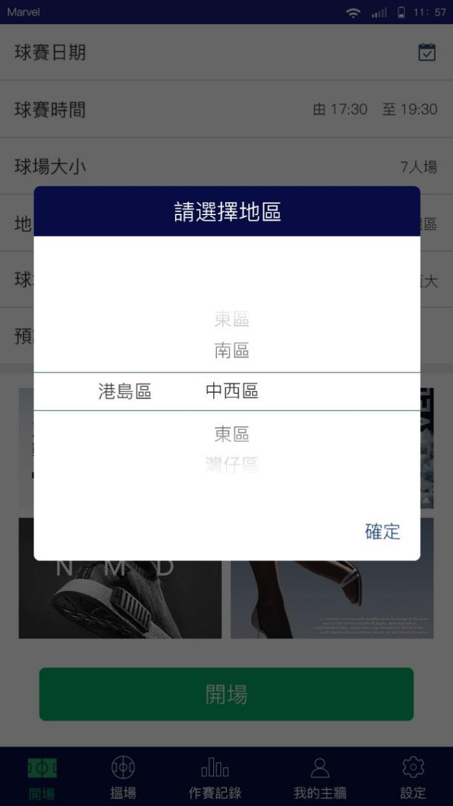

**Choose Your District**

**Hong Kong**

Central and Western

Eastern

Southern

Wan Chai

**Kowloon**

Kowloon City

Kwun Tong

Sham Shui Po

Wong Tai Sin

Yau Tsim Mong

**New Territories**

Islands

Kwai Tsing

North

Sai Kung

Sha Tin

Tai Po

Tsuen Wan

Tuen Mun

Yuen Long

**Confirm55**

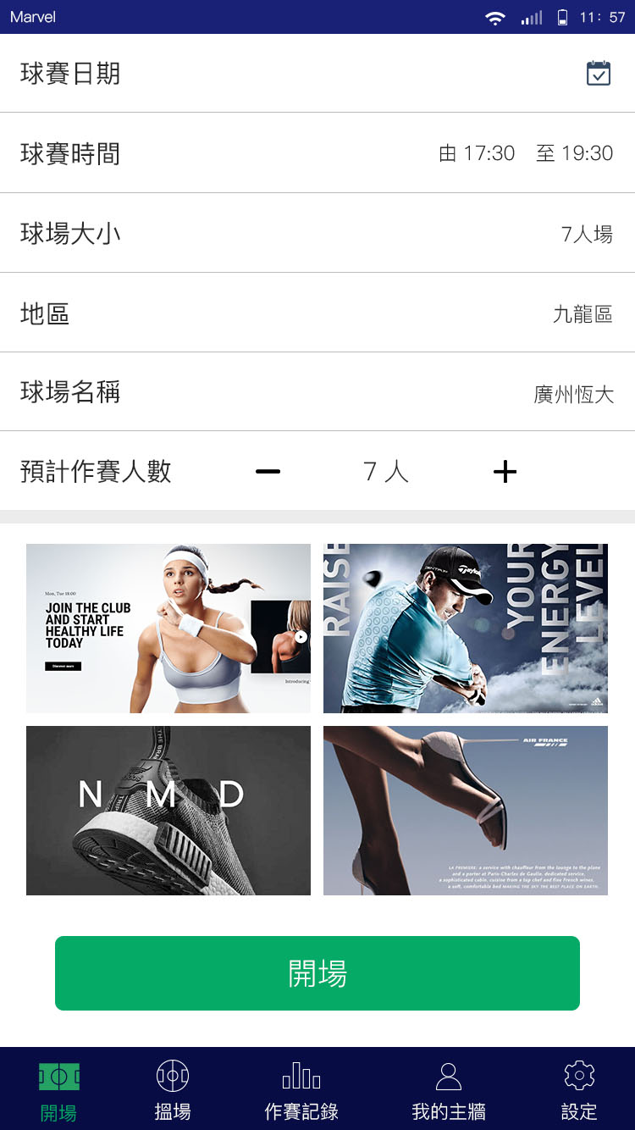

**Match Date**

**Match Time**

From 17:30 to 19:30

**Pitch Size**

5-a-side pitch

7-a-side pitch

**District**

Hong Kong

Kowloon

New Territories

**Name of Venue**

**Expected Number of Players**

**Settings**

**My Wall**

**Join Match**

**Create Match**

**Create Match**

**Fixtures & Records**

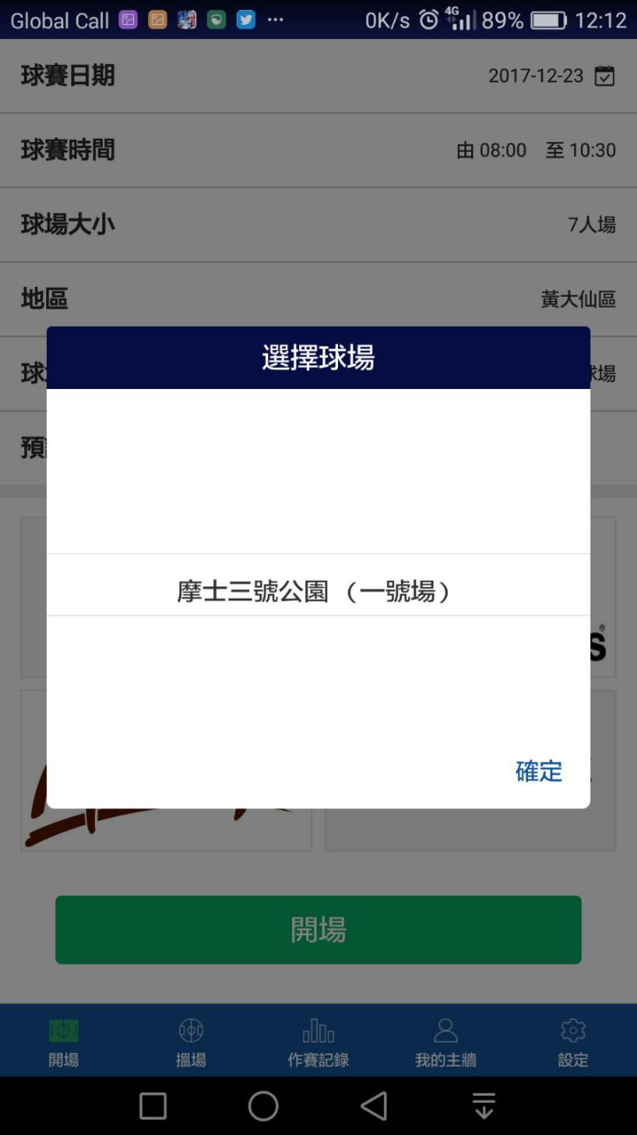

**Choose Your Venue**

**Morse Park No.3 (Soccer Pitch No. 1)**

**Confirm**

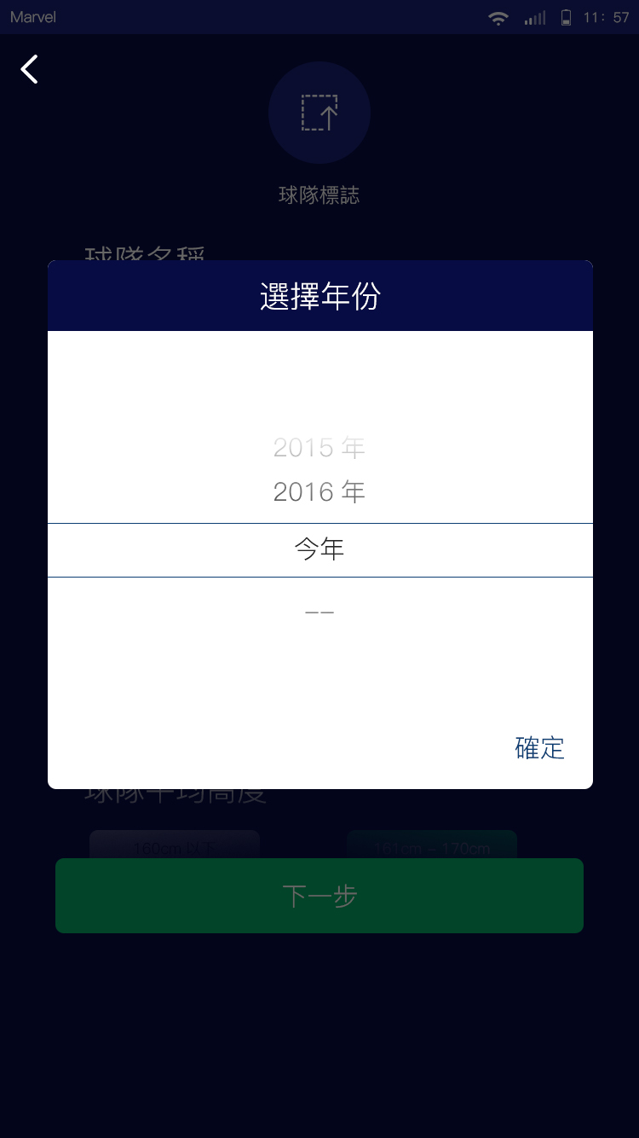

**Next**

2015

2016

2017

This year

**Confirm**

**Confirm**

**Choose the Year**

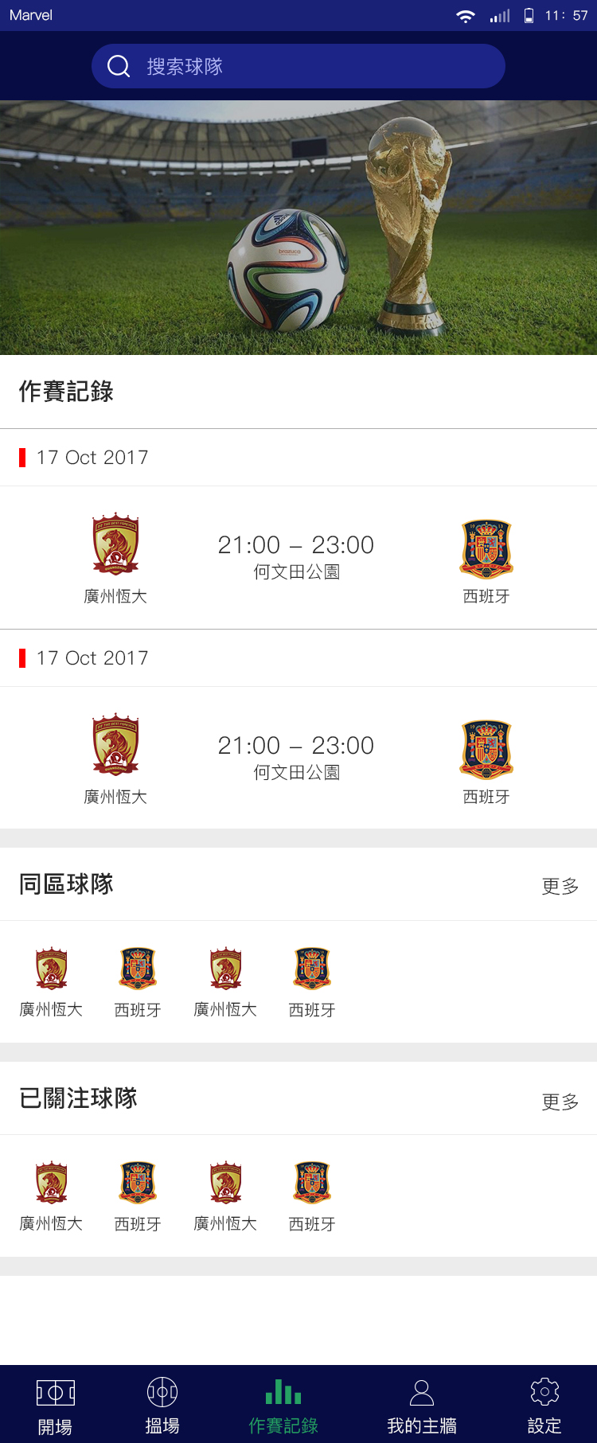

**Teams in Same District**

**Fixtures & Records**

**More**

**More**

**Following Teams**

**Search Team**

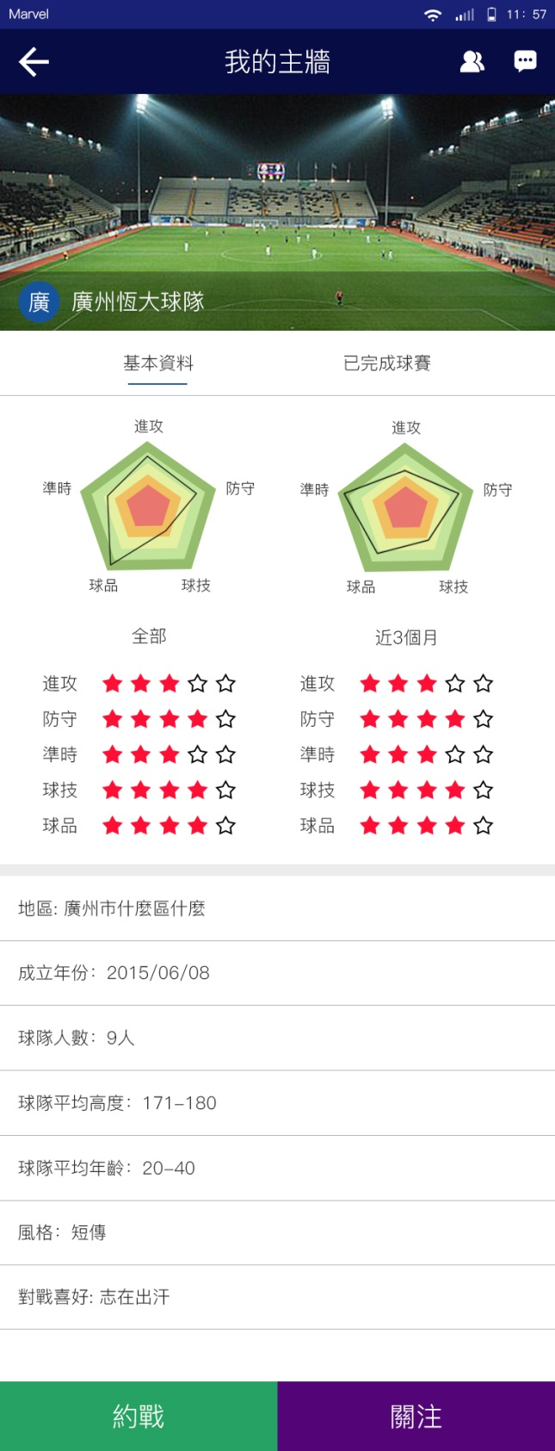

**Basic Information Completed Matches**

**All Last 3 months**

**Attack**

**Defense**

**Punctuality**

**Technique**

**Character**

**District**

**Established Year**

2015/06/08

**Number of Players**

9

**Average Height of Players**

171 – 180

**Age Range of Players**

20-40

**Style**

Defensive

Offensive

Short pass

Long pass

**Match Preference**

Non-competitive

Competitive

**My Wall**

**Follow**

**Match**

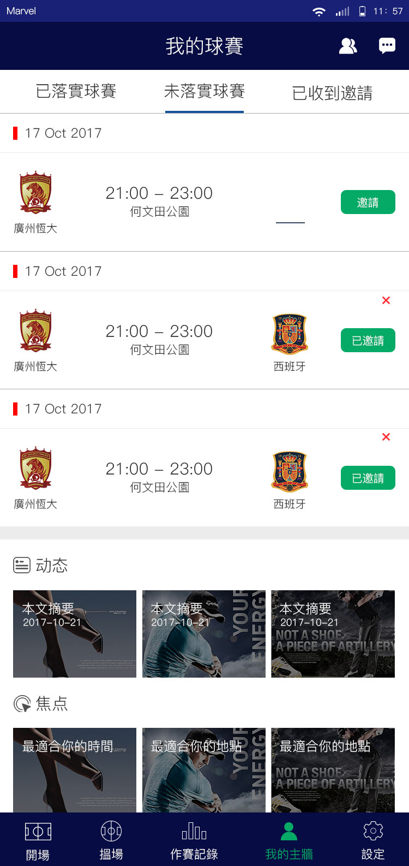

**Invite**

**Featured District**

**Featured Time**

Article summary

**Suggestions**

**Recent News**

**Invited**

**Confirmed Matches**

**Pending**

**Invitations Received**

**P**

**My Wall**

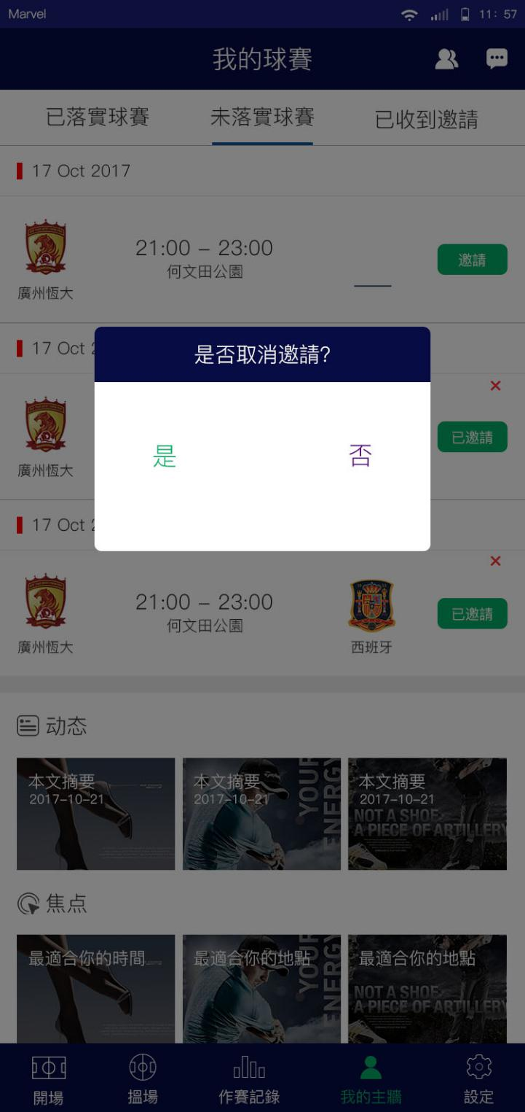

**Cancel the Invitation?**

Yes No

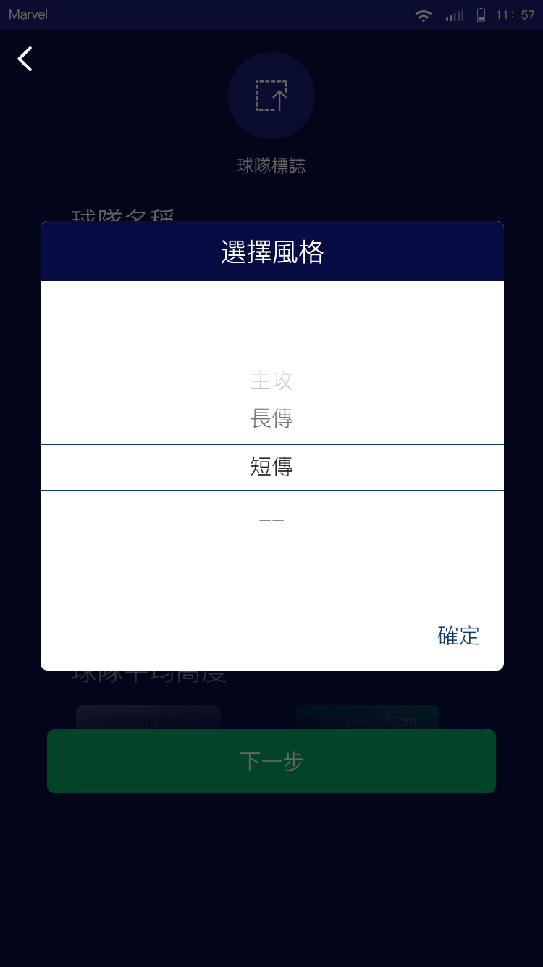

**Choose Your Style**

Defensive

Offensive

Long Pass

Short Pass

Confirm

**Next**

**Notifications**

**Inbox**

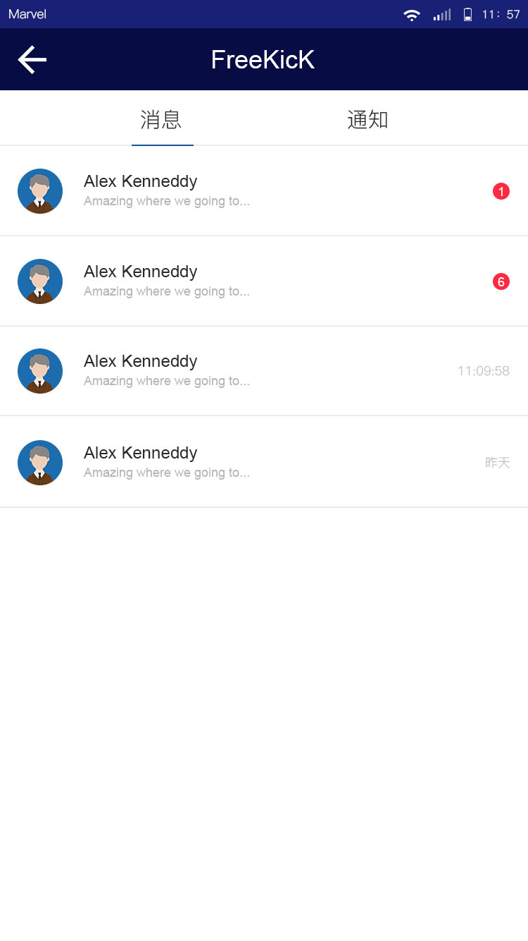

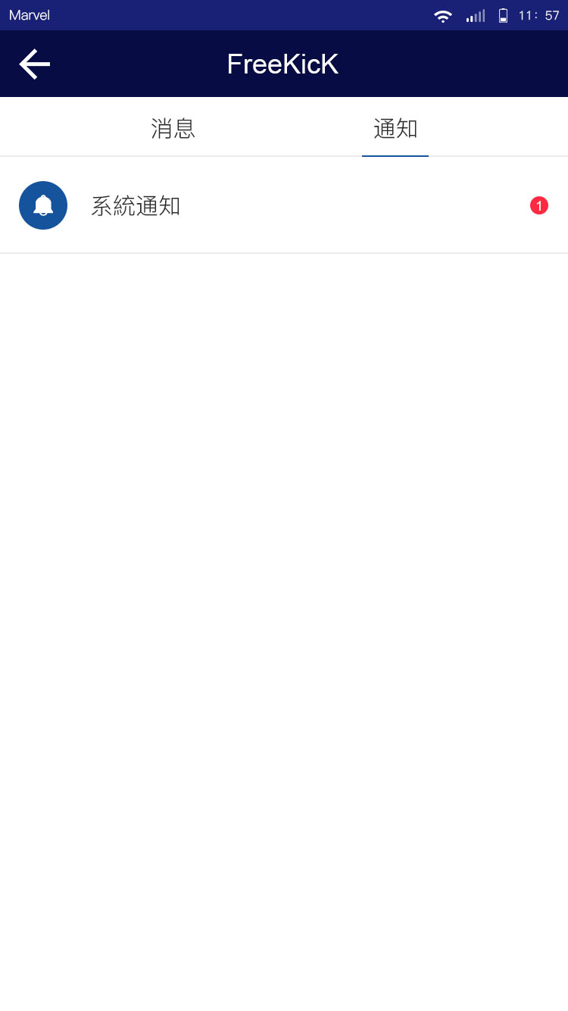

System Notifications

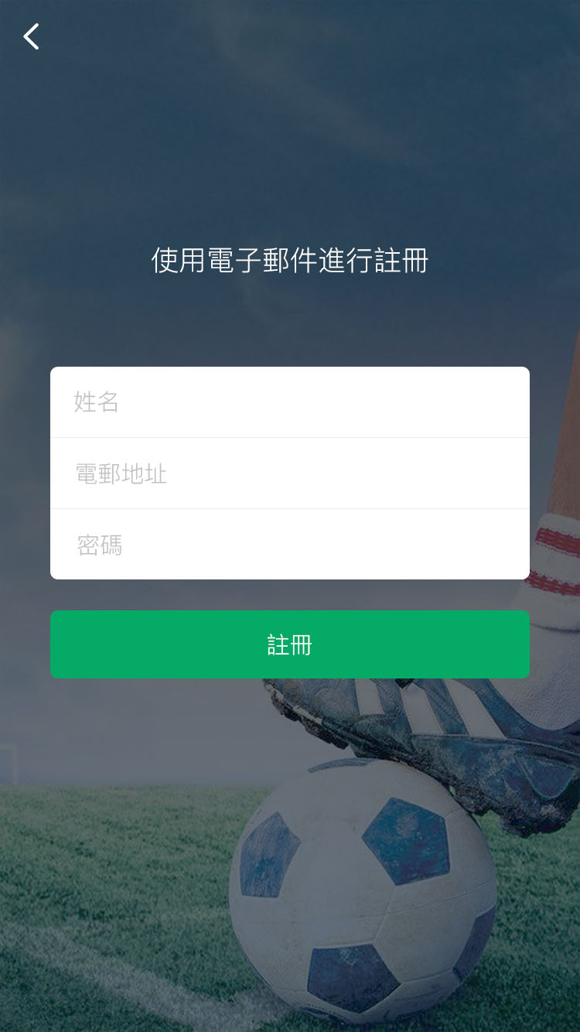

Sign Up

Password

Email

Full Name

Sign up with email

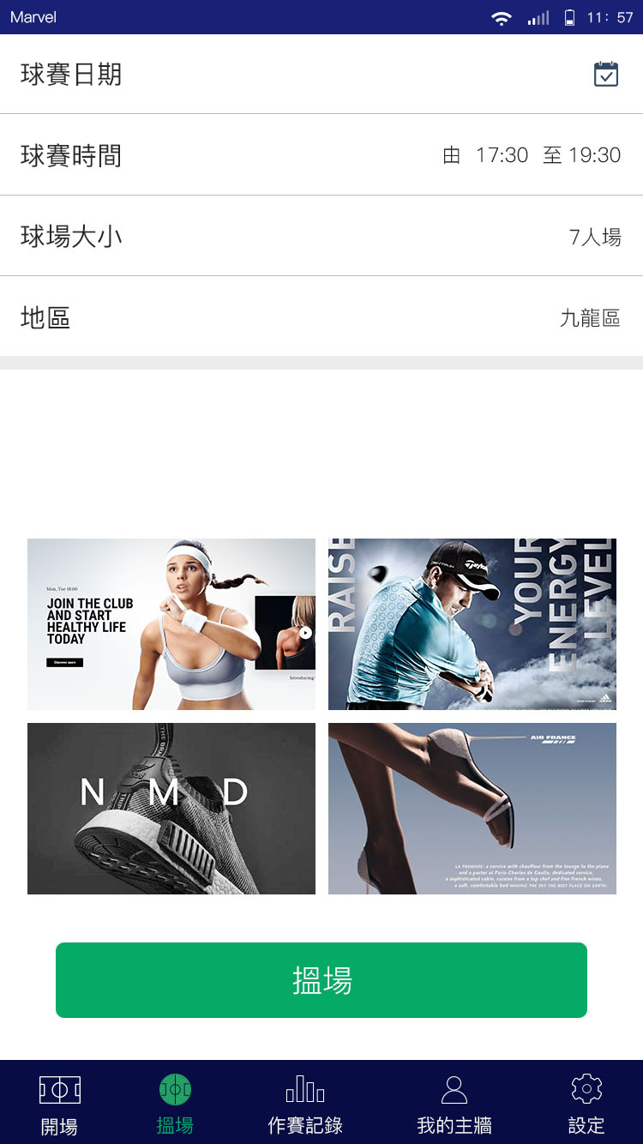

**Match Date**

**Match Time**

From 17:30 to 19:30

**Pitch Size**

5-a-side pitch

7-a-side pitch

11-a-side pitch

**District**

Hong Kong

Kowloon

New Territories

**Join Match**

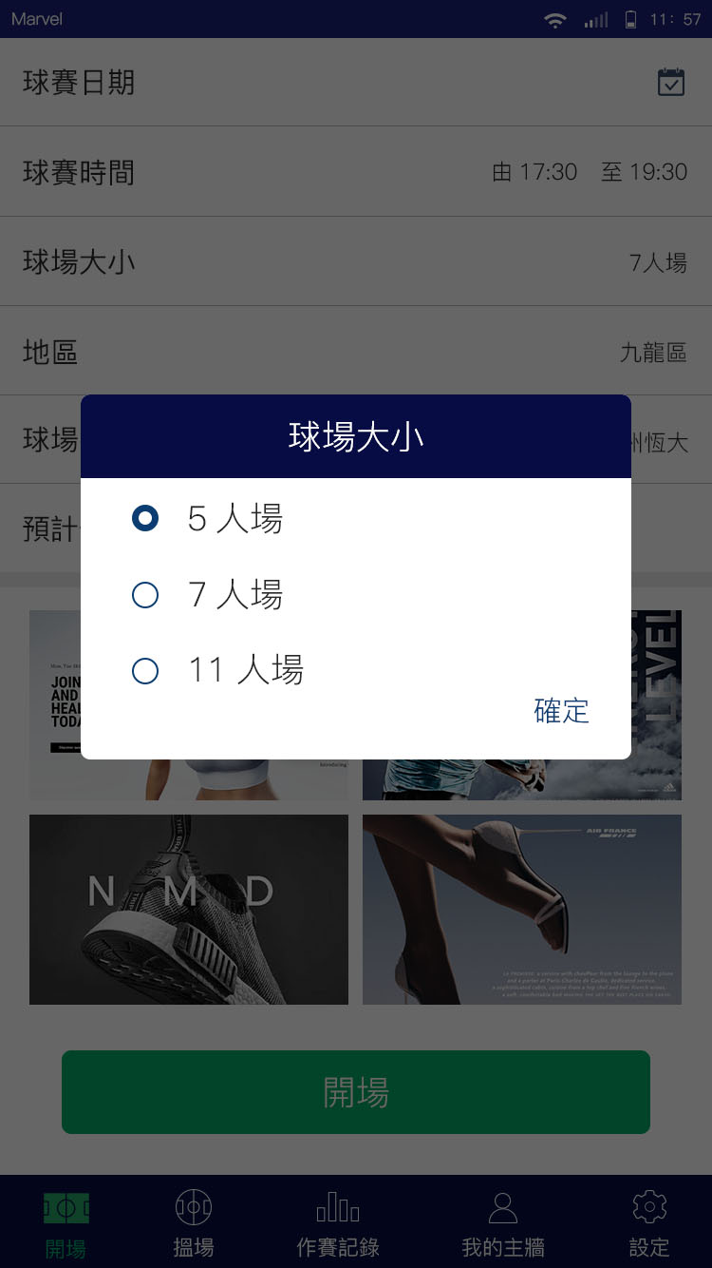

**Pitch Size**

5-a-side pitch

7-a-side pitch

**Confirm**

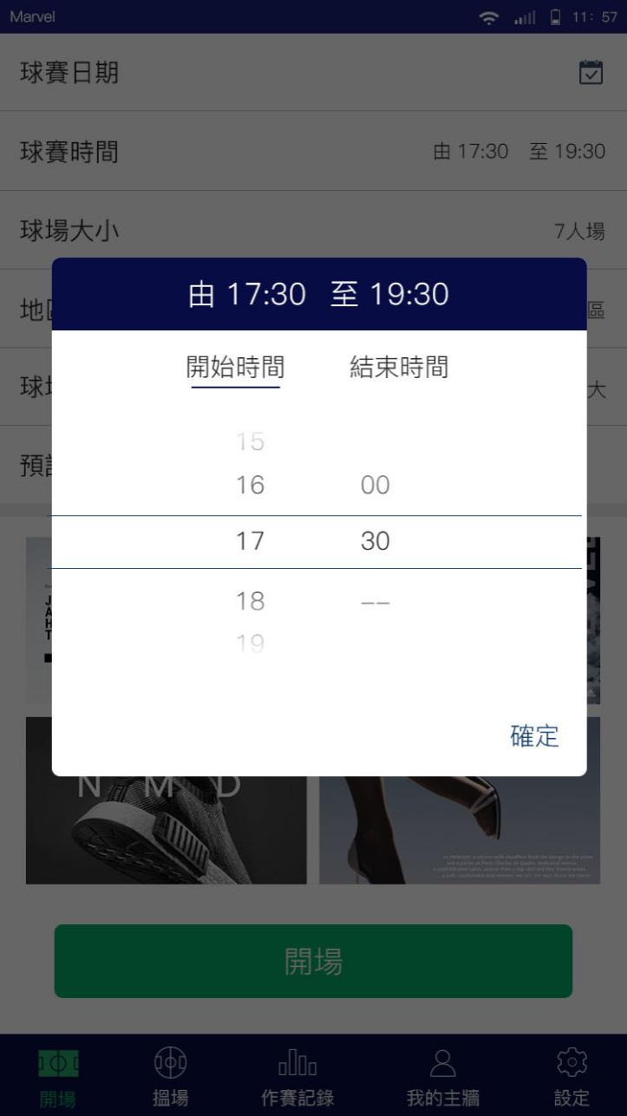

**From 17:30 to 19:30**

**Start Time End Time**

**Confirm**

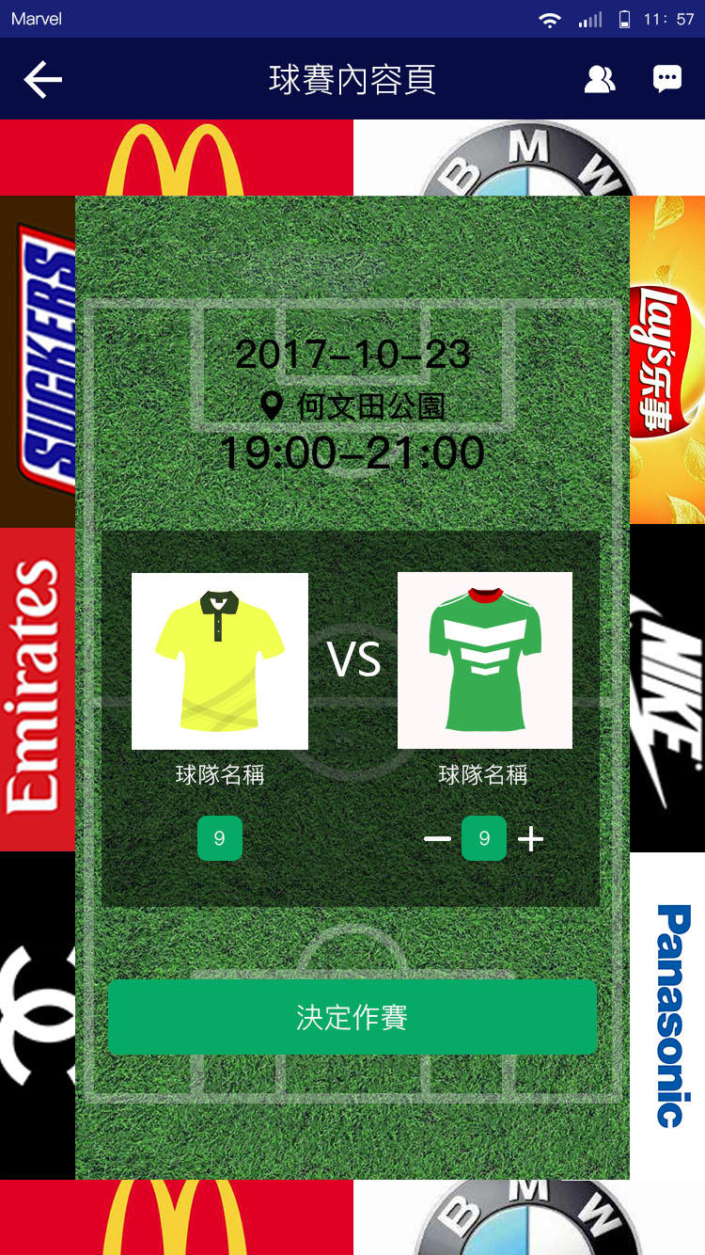

**Confirm Match**

**Team Name**

**Match Content Page**

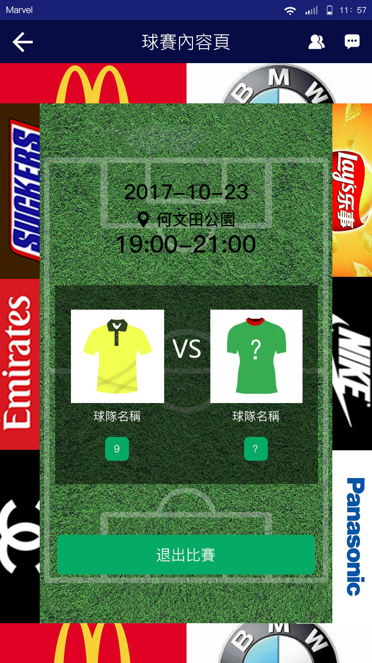

**Withdraw Match**

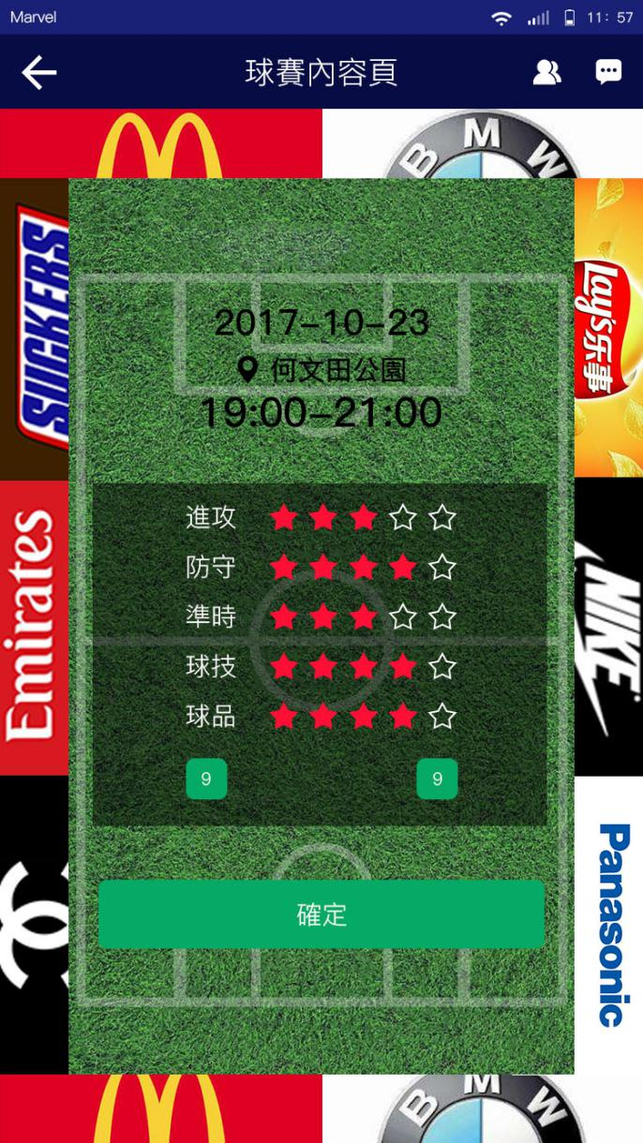

**Attack**

**Defense**

**Punctuality**

**Technique**

**Character**

**Confirm**

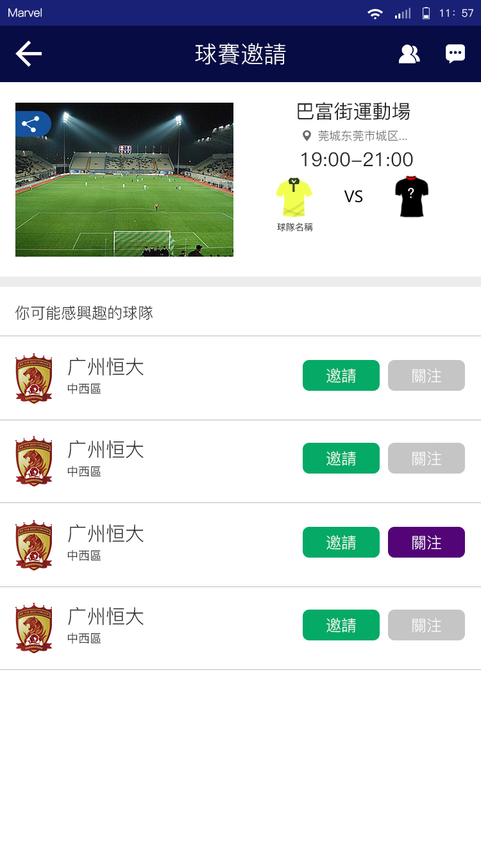

Teams you may be interested in

Invite Follow

**Match Invitations**

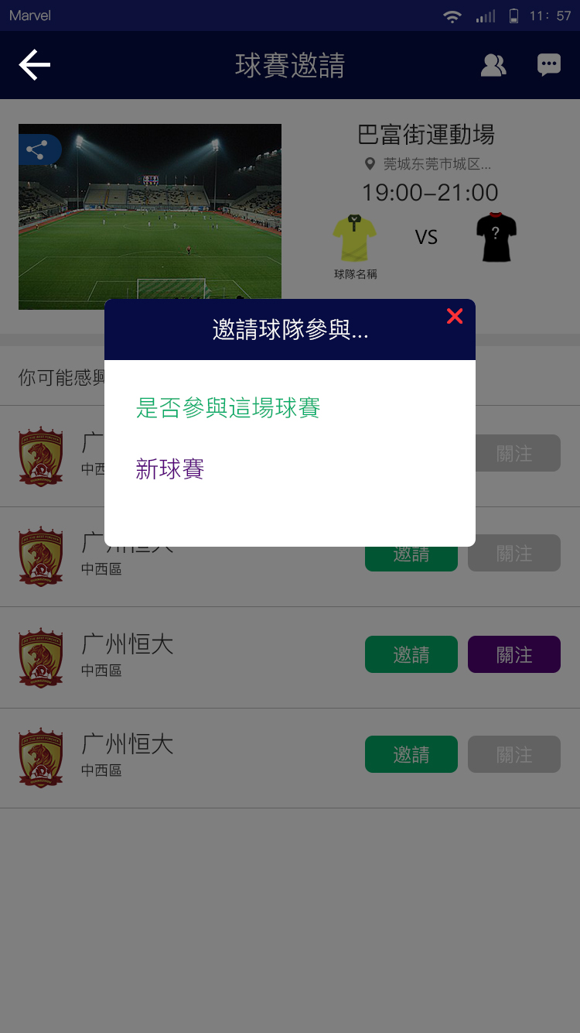

**Invite team to join…**

This match

A new match

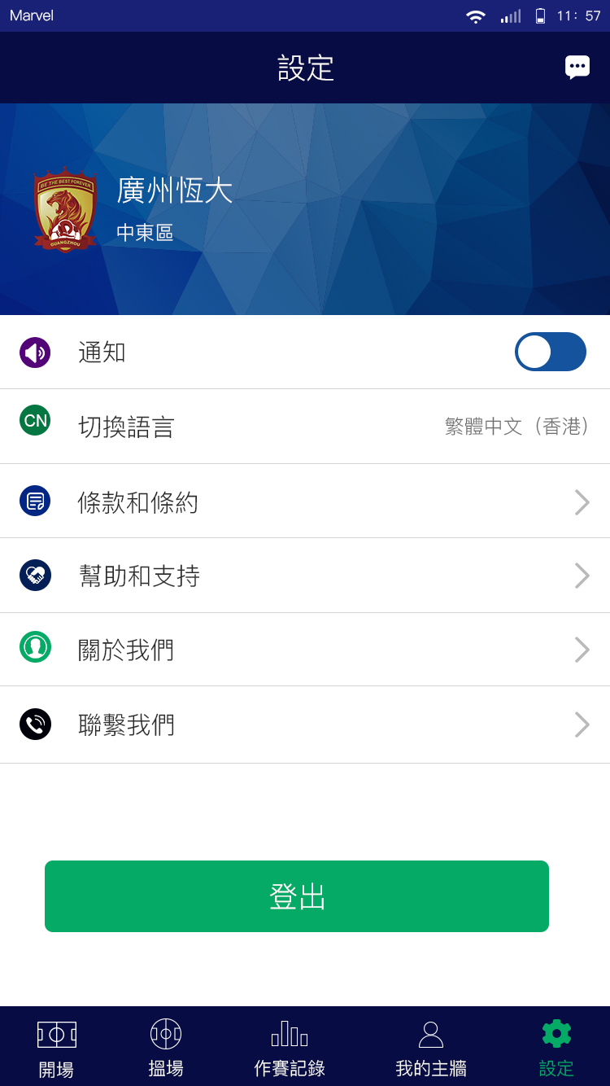

**Logout**

**Contact Us**

**About Us**

**Help and Support**

**Terms and Conditions**

**Language**

Chinese (Traditional)

English

**Notifications**

**Settings**

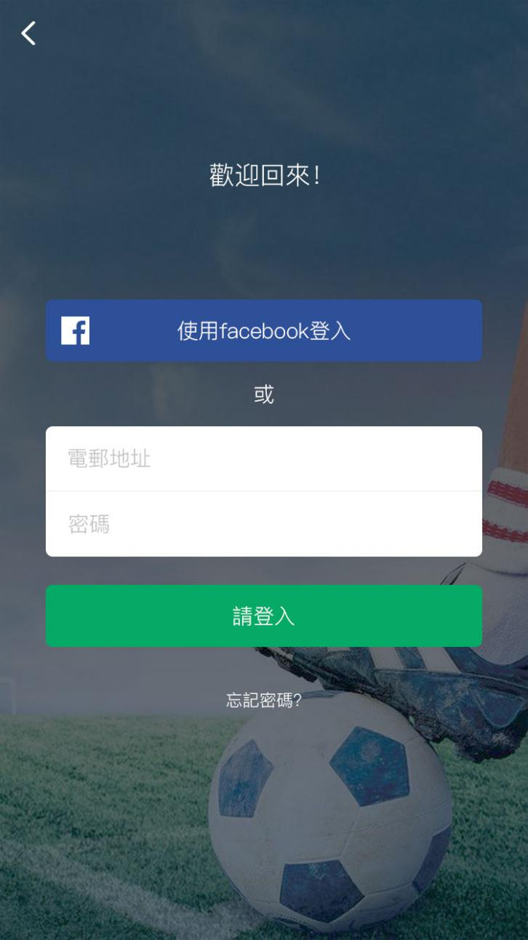

Forgot password?

Login

Password

Email

or

Log in with Facebook

Welcome back!

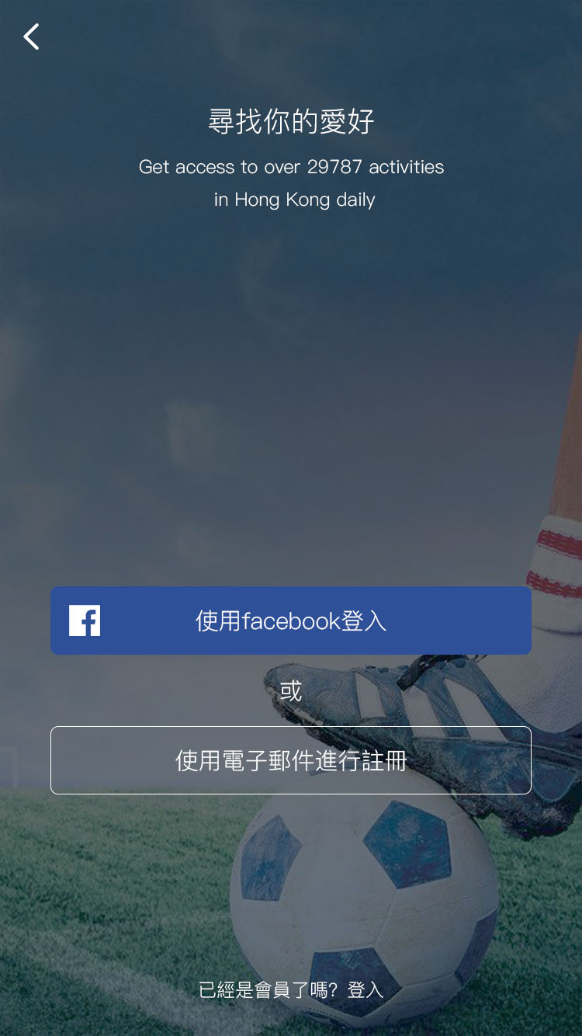

Already a Freekicker? Login

Sign up with email

or

Log in with Facebook

Discover football match

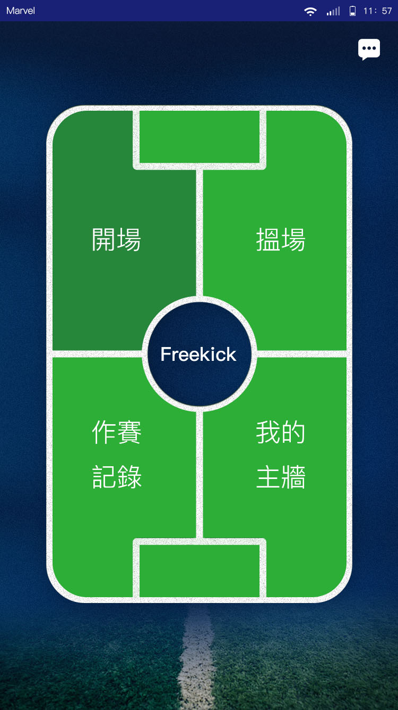

**My Wall**

**Create Match Join Match**

**Fixtures & Records**

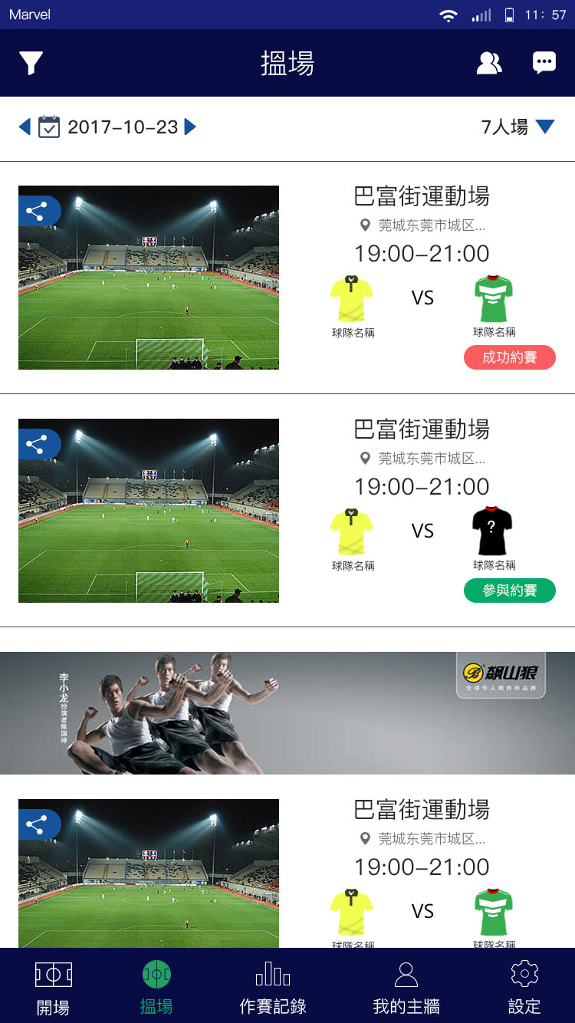

Available Match

Confirmed Match

7-a-side pitch

Join Match

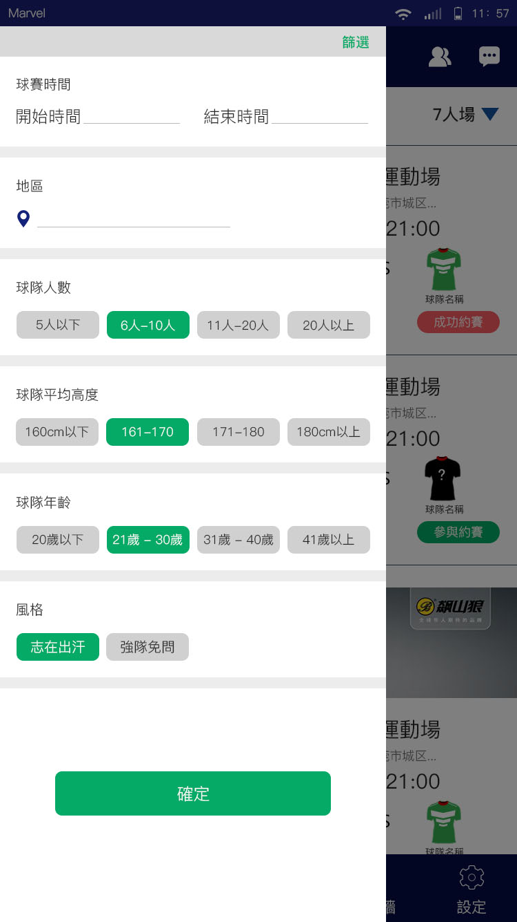

**Filter**

**Match Time**

Start Time End Time

**District**

**Number of Players**

5 or below

6 to 10

11 to 20

Above 20

**Average Height of Players**

160cm or below

161 - 170

171 – 180

Above 180cm

**Age Range of Players**

Age 20 or below

Age 21 – Age 30

Age 31 – Age 40

Above age 40

**Match Preference**

Competitive

Non -competitive

**Confirm**

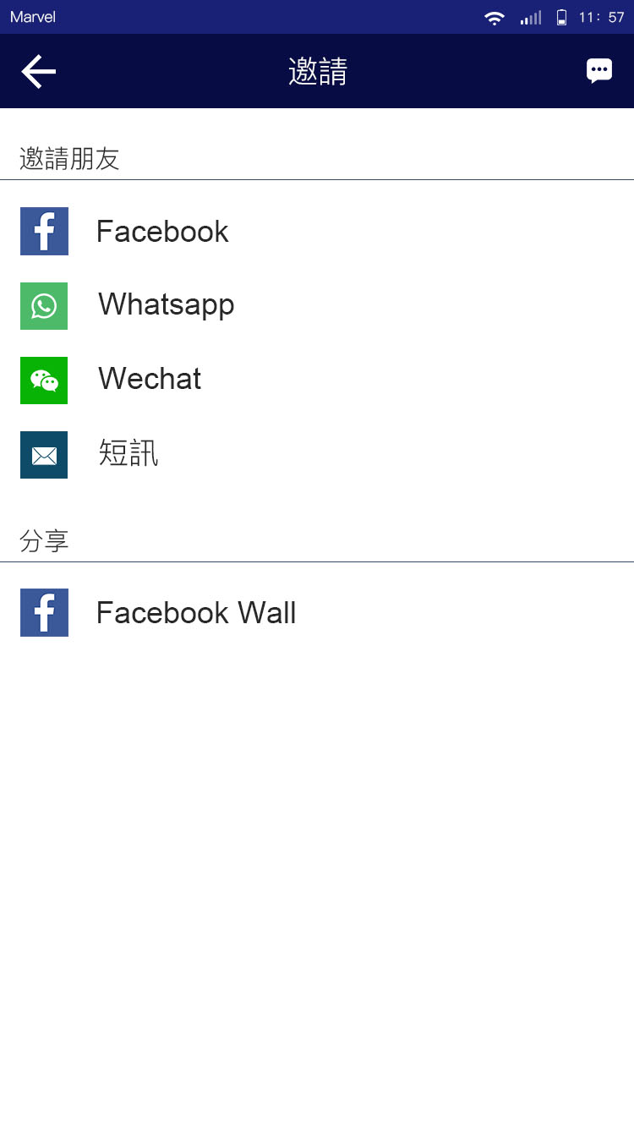

Share

Messages

Invite friends

Invitations

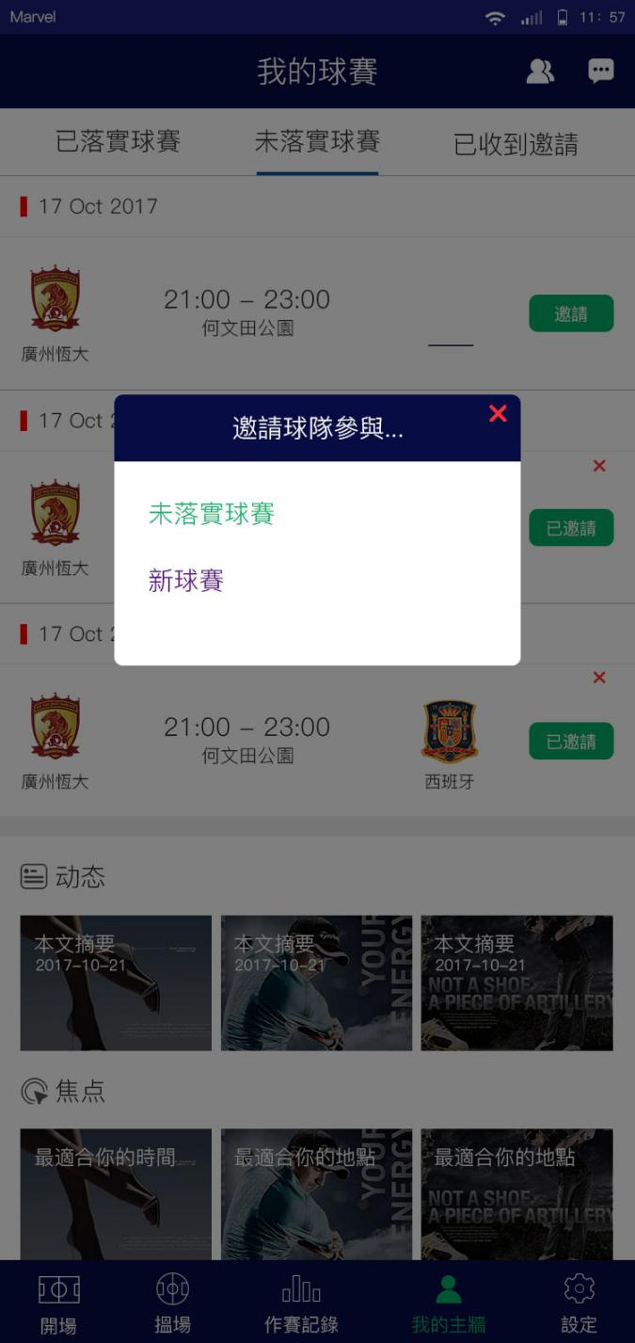

Invited

Invite

**Invite team to join…**

The pending match

A new match

N2: 註冊完喇，快d約番場波啦！

Registration is completed. Let's create match!

N3: 提提你：有場紙同夠一隊先好去約波呀！

Reminder : Please ensure that you got the pitch reservation and gathered enough teammates before creating a match!

N4: 機會黎喇，飛雲！ABC 足球隊想邀請你踢返場波。

Here is your chance: ABC team has just sent you a match invitation!

N5: 搞掂喇！終於可以踢返場波啦！

雙方資料

球賽資料

波衫顏色

It’s done! Time to play football!

Information of both sides

Match information

Jersey color

N6: 唔好話我唔提醒你：聽日有場波等緊你

Reminder: Don’t miss out the match tomorrow!

N7a: 你已成功取消與Xxx的球賽。

日期：

時間：

地點:

The match with XXX have been successfully cancelled.

Date:

Time:

Place:

N7b: 唔好意思，ABC已取消同你的球賽。

日期：

時間：

地點：

1. 人黎，同朕check下其他球隊！

2. 好叻咩，唔踢咪唔踢囉！

Sorry, the match is being cancelled by ABC team.

Date:

Time:

Place:

1. Hey, please check out any other available team for me!
2. It’s ok. No need to match up another team for me this time.

N7c: 唔好意思，Xxx已取消同你的球賽。

日期：

時間：

地點：

1. 人黎，同朕check下其他球隊！

2. 唔急既，再等下先啦！

3. 好叻咩，唔踢咪唔踢囉！

Sorry, the match is being cancelled by ABC team.

Date:

Time:

Place:

1. Hey, please check out any other available team for me!
2. It’s not urgent, just wait for another team to match up!
3. It’s ok. No need to match up another team for me this time.

N8(主隊收）：你最期待既畫面出現喇！有球隊應約喇。

Congratulations! A team joins the match!

N9a(黃雨/紅雨/三號波或以下）

踢波先黎落雨，

1. 落雨有咩好怕喎，照踢！

2. 聽日一定會好天既，下次再踢。

Here comes the rain again!

1. We still want to play the game! Our determination for football outreach any circumstances!
2. Please cancel the match for us, we will play next time.

N9b(黑雨/8號波或以上）

由於天氣惡劣，球場嚴重水浸，波友應留在安全地方暫避，今日場波將會取消。

Due to the bad weather, there will be serious flooding in the pitch and freekickers should stay in safe place. Today’s match will be cancelled.

N10 賽後你點睇，請為今日既對手評分

What is your comment after the match? Please rate your opponent.

N11（女神已accept某球隊）

Xxx已經拒絕你的對賽請求

日期

時間

地點

Xxx has rejected your match request

Date:

Time:

Place:

N12 你已被xxx邀請

Xxx has just sent you a match invitation.

N13 由於在限時內xxx未有確認，系統將自動取消以下比賽：

日期

時間

地點

We have not received any reply from xxx with the time limit. Your match invitation is now cancelled by the system:

Date:

Time:

Place:

N14你已被xxx關注

xxx started following you.